OOP

CT/2021/075

Q1)

package Q_1;  
  
public class Numbers {  
 public static void main(String[] args) {  
  
 for (int i = 10; i <= 49; i++) {  
 System.*out*.print(i + " ");  
  
 if ((i + 1) % 10 == 0) {  
 System.*out*.println();  
 }  
 }  
 }  
 }

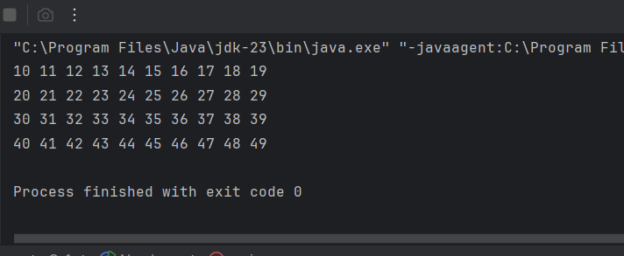

Q2)

package Q_2;  
import java.util.Scanner;  
public class Digit {  
 public static int countDigits(int number) {  
 int count = 0;  
 do {  
 count++;  
 number /= 10;  
 } while (number != 0);  
 return count;  
 }  
 public static void main(String[] args) {  
 Scanner scanner = new Scanner(System.*in*);  
 int input;  
   
 while (true) {  
 System.*out*.print("Enter a positive integer (negative number to quit): ");  
 input = scanner.nextInt();  
  
 if (input < 0) {  
 System.*out*.println("Negative number entered. Exiting...");  
 break;  
 }  
  
 int digits = *countDigits*(input);  
 System.*out*.println("Number of digits: " + digits);  
 }  
  
 scanner.close();  
 }  
 }

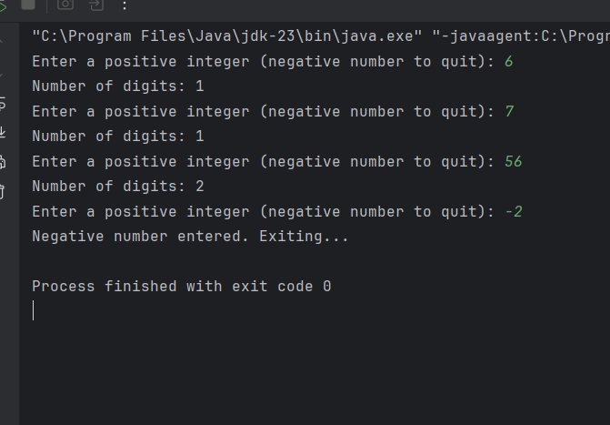

Q3)

package Q_3;  
import java.util.Scanner;  
public class MultiplicationTable {  
 public static void main(String[] args) {  
 Scanner scanner = new Scanner(System.*in*);  
   
 System.*out*.print("Enter a number to print its multiplication table: ");  
 int n = scanner.nextInt();  
   
 System.*out*.println("Multiplication Table for " + n + ":");  
 for (int i = 1; i <= 10; i++) {  
 System.*out*.println(n + " x " + i + " = " + (n * i));  
 }  
  
 scanner.close();  
 }  
 }

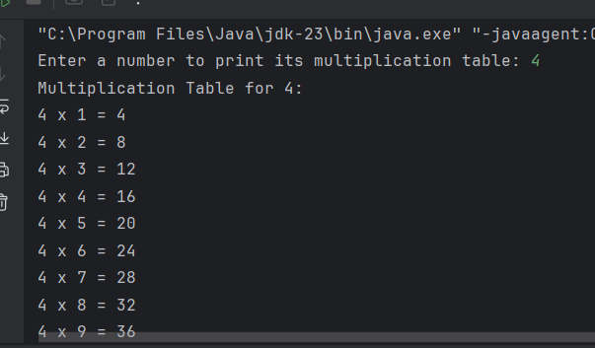

Q4)

package Q_4;  
import java.util.Scanner;  
public class Asterisks {  
 public static void main(String[] args) {  
 Scanner scanner = new Scanner(System.*in*);  
  
 System.*out*.print("Enter the number of rows for the pyramid: ");  
 int rows = scanner.nextInt();  
 for (int i = 1; i <= rows; i++) {  
 for (int j = 1; j <= rows - i; j++) {  
 System.*out*.print(" ");  
 }  
 for (int k = 1; k <= (2 * i - 1); k++) {  
 System.*out*.print("*");  
 }  
  
 System.*out*.println();  
 }  
  
 scanner.close();  
 }  
 }

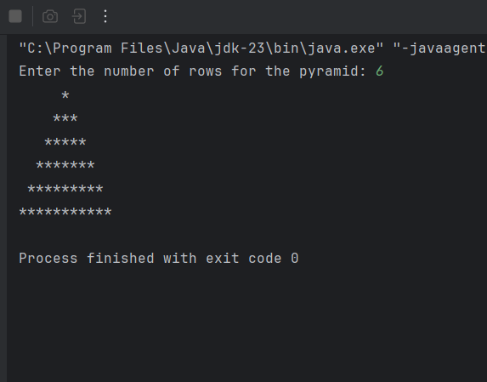

Q5)

package Q_5;  
import java.util.Scanner;  
public class Palindrome {  
 public static boolean isPalindrome(String text) {  
 String cleaned = text.replaceAll("[^a-zA-Z0-9]", "").toLowerCase();  
 String reversed = new StringBuilder(cleaned).reverse().toString();  
 return cleaned.equals(reversed);  
 }  
 public static void main(String[] args) {  
 Scanner scanner = new Scanner(System.*in*);  
 System.*out*.print("Enter a word or phrase: ");  
 String input = scanner.nextLine();  
 if (*isPalindrome*(input)) {  
 System.*out*.println("It is a palindrome.");  
 } else {  
 System.*out*.println("It is not a palindrome.");  
 }  
  
 scanner.close();  
 }  
 }

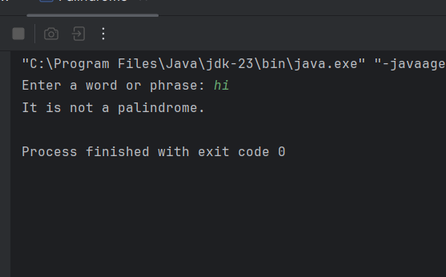

Q6)

package Q_6;  
import java.util.Scanner;  
import java.util.Random;  
public class RandomNumber {  
 public static void main(String[] args) {  
 Scanner scanner = new Scanner(System.*in*);  
 Random random = new Random();  
 int targetNumber = random.nextInt(100) + 1;  
 int guess;  
  
 System.*out*.println("Guess the number (between 1 and 100):");  
  
 while (true) {  
 System.*out*.print("Enter your guess: ");  
 guess = scanner.nextInt();  
  
 if (guess < targetNumber) {  
 System.*out*.println("Higher!");  
 } else if (guess > targetNumber) {  
 System.*out*.println("Lower!");  
 } else {  
 System.*out*.println("Congratulations! You guessed the correct number.");  
 break;  
 }  
 }  
  
 scanner.close();  
 }  
 }

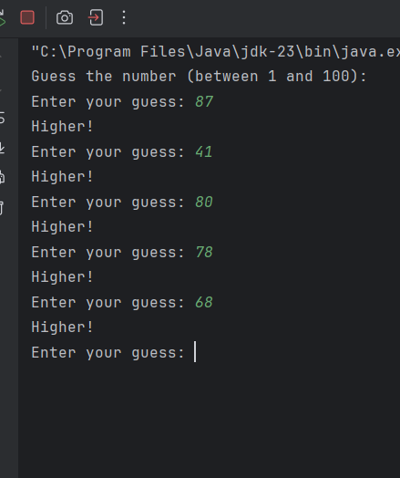

Q7)

package Q_7;  
import java.util.Scanner;  
public class WordReplace {  
 public static void main(String[] args) {  
 Scanner scanner = new Scanner(System.*in*);  
   
 System.*out*.print("Enter a sentence: ");  
 String sentence = scanner.nextLine();  
   
 System.*out*.print("Enter the word to replace: ");  
 String targetWord = scanner.nextLine();  
  
 System.*out*.print("Enter the replacement word: ");  
 String replacementWord = scanner.nextLine();  
  
 String updatedSentence = sentence.replaceAll("\\b" + targetWord + "\\b", replacementWord);  
   
 System.*out*.println("Updated sentence: " + updatedSentence);  
  
 scanner.close();  
 }  
 }

